iOS Mobile App Instrumentation Procedure

Step 1:
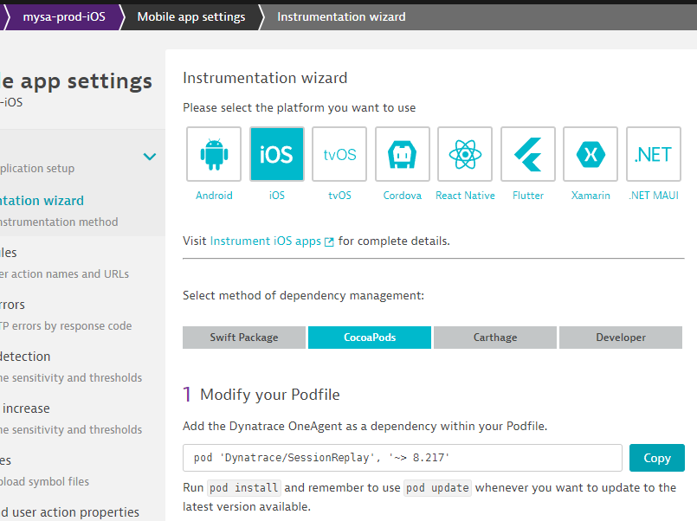
pod 'Dynatrace/SessionReplay', '~> 8.217'
Step 2:
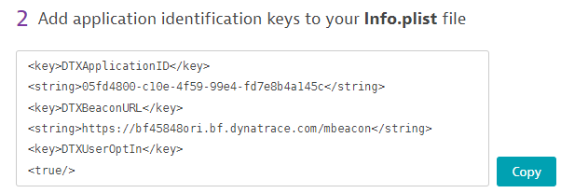
<key>DTXApplicationID</key>
<string>05fd4800-c10e-4f59-99e4-fd7e8b4a145c</string>
<key>DTXBeaconURL</key>
<string>https://bf45848ori.bf.dynatrace.com/mbeacon</string>
<key>DTXUserOptIn</key>
<true/>

Step 3:
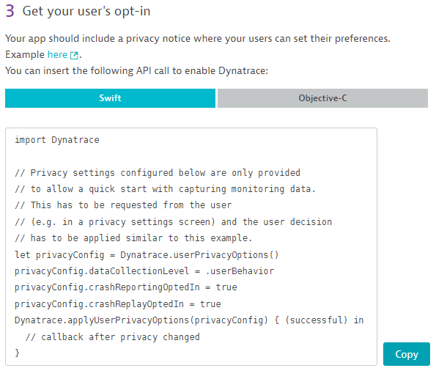
import Dynatrace
// Privacy settings configured below are only provided
// to allow a quick start with capturing monitoring data.
// This has to be requested from the user
// (e.g. in a privacy settings screen) and the user decision
// has to be applied similar to this example.
let privacyConfig = Dynatrace.userPrivacyOptions()
privacyConfig.dataCollectionLevel = .userBehavior
privacyConfig.crashReportingOptedIn = true
privacyConfig.crashReplayOptedIn = true
Dynatrace.applyUserPrivacyOptions(privacyConfig) { (successful) in
// callback after privacy changed
}

Step 4 & 5:
